DATE: 03.05.2019
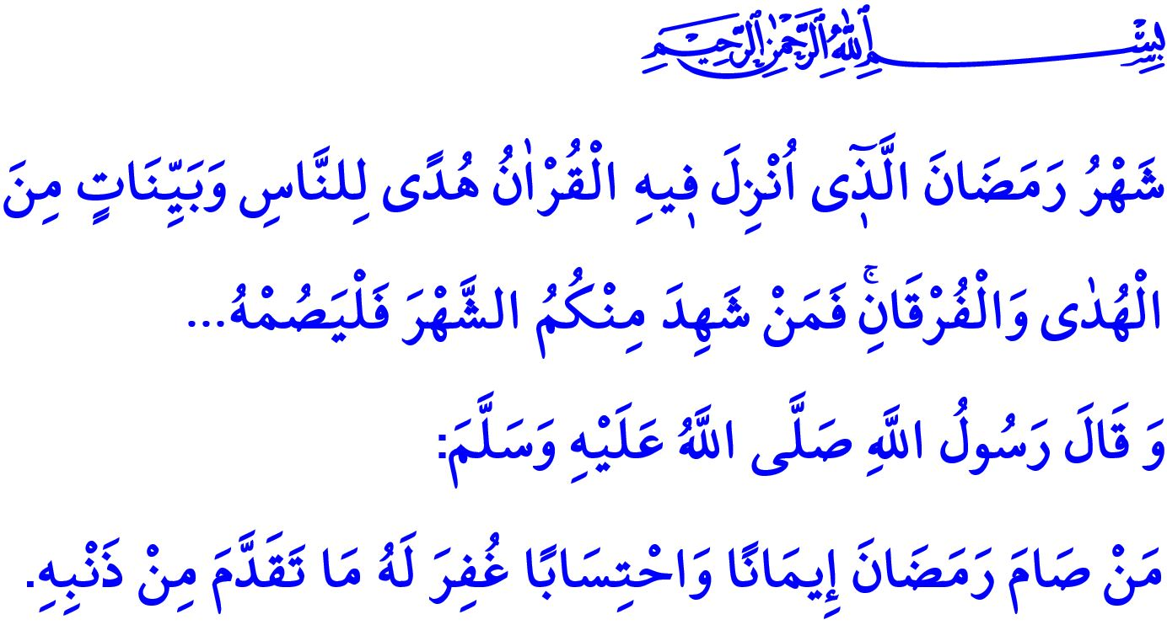
WELCOME, THE MONTH OF RAMADAN!
Dear Muslims!
We will have reached Ramadan, the Sultan of the Months, with the tarawih prayer following the isha prayer the next Sunday. The same night we will wake up for sahur to start fasting, and enter the season of blessing and mercy, inshaallah.
May endless praise be to Allah (swt) who have allowed us to reach Ramadan. May salat and salam be to the Prophet Muhammad (saw), of whose ummah we are honored to be members.
Honorable Believers!
The month of Ramadan is the month of blessing that we have for one year longed for. It is an unprecedented period of time in which faith, worship, good morality, consciousness of being ummah, and brotherhood in Islam are consolidated. It is the time for Muslims to review their relationship with Allah on the one hand, and with their brothers and sisters on the other, thereby questioning their own selves. With the peacefulness of reaching such a sacred month, the Prophet Muhammad said to his companions, “The month of Ramadan has come with its blessings. Allah enriches you, blesses you, conceals mistakes, and accepts your prayers and du’as in this month. The Almighty Allah (swt) takes into account rather your competition in benevolence, and praises you to His angels. Then, do your best to be prominent in your efforts in good deeds and benevolence. The miserable is whoever is deprived of Allah (swt)’s mercy in Ramadan.”
Honorable Believers!
Ramadan is the month in which the worship of fasting, which turns us into pious Muslims as patient and contented, was made obligatory. It is the month in which the Holy Qur’an, our guide to true path and salvation, was started to be revealed. Allah the Exalted (swt) refers to it as follows, "Ramadan is the month in which the Qur'an was revealed as a guide for humanity with clear proofs of guidance and the standard to distinguish between right and wrong. So, whoever is present this month, let them fast..."
Ramadan is the month of repentance which purifies Muslims from sins like autumn rains at the end of summer washing the dirt and dust away from the earth. Likewise, the Prophet Muhammad (saw) says, "Whoever observes fasts during the month of Ramadan out of sincere faith, and hoping to attain Allah's rewards, then all his past sins will be forgiven."
Honorable Muslims!
The Month of Ramadan is the most valuable harvest season of our lives and an opportunity of material and spiritual renewal for all of us. It is a hope, excitement and awakening for Muslims. It is the mobilization of hearts, during which the poor, the almsman, the needy and the lonely are remembered and protected by means of infaq (spending in the way of Allah (swt)). Those people who do not know the value of Ramadan though reaching it will be deprived of a great treasure!
Dear Believers!
The places where the sacred month of Ramadan is best experienced are the mosques in which the hearts of Muslims are filled with peacefulness as they stand in prayer. The mosques, in which we as Muslims purified of all our senses of self-centrism submit our servitude to Allah, are the heart of the Islamic civilization. Our mosques are constructed thanks to the efforts, sacrifices, material and non-material support of our noble nation. The adhans echoing around over nintey thousand mosques today in our country are the symbols of our independence and of our future. One such mosque is the Istanbul Great Çamlıca Mosque, which is Turkey’s greatest and will be opened officially today. I would like to take this opportunity to commemorate, in gratitude, all those charitable people who have lead the way for, and supported, the construction, maintenance, and rendering prosperous of mosques, from the past to the present.
Honorable Muslims!
Let us try to benefit from the barakah of Ramadan. Let us bring our houses and hearts together with Qur’an in the month of Qur'an. Let us try to maintain the tradition of gathering for reciting the Qur’an, as done by the Prophet Muhammad (saw) Let us try to attend the sermons and the tarawih prayers altogether, men and women, children and youth. [i] Let us make those people in need smile with the zakat and sadaqah that we will give. Let us try to be among those people to spend this sacred month in the best way, as expressed by the Prophet Muhammad (saw), from the first night of which the devils are chained up, the gates of the Hell are closed, of the Heaven are opened, and countless Muslims are saved from the fire of the Hell.

Haythami, Majmua al-Zawaid, III, 344.
Baqarah, 2/185.
Bukhari, Iman, 28.
Tirmidhi, Sawm, 1; Ibn Majah, Siyam, 2. General Directorate of Religious Services

